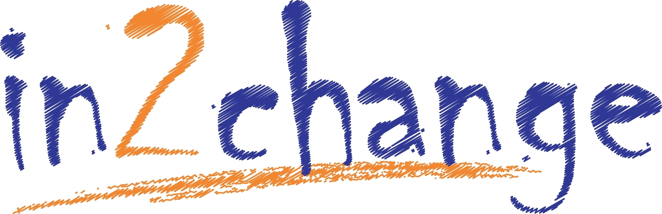

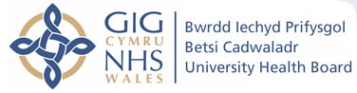

Guidance for Referrers
To assist us in providing the best possible service and support to young people, please ensure you follow the checklist and all information is complete.

Checklist
- The young person is aware and consents to the referral
- The Young person lives in or attends education in Wrexham
- The young person is aged between 11 and 18 (inclusive)
(if not, contact in2change for advice regarding the appropriate service to refer to)
- Referral form completed with as much information as possible
- DUST form completed with Young person and the score calculated
- Risk Assessment is completed and included with referral

You can send the referral marked ‘Private and Confidential’ via:
  - E mail: in2change@wrexham.gov.uk
(Please ensure it is password protected)

- For any queries, please contact the in2change team on their work mobiles as we are currently working from home.

Elise Williams - Coordinator for in2change 07800 999071
Ruby Armstrong Twigg - Young Persons Substance Misuse Worker 07557 930700
Adam Harvey - Young Persons Substance Misuse Worker 07876 657295

Am wybodaeth ynglyn a sut mae Cyngor Bwrdeistref Sirol Wrexham yn defnyddio data personol, gweler yr rhybydd Preifarwydd ar ein safle gwefan: www.wrecsam.gov.uk
For information as to how Wrexham County Borough Council handles personal data, please see our Privacy Notices on our website: www.wrexham.gov.uk

