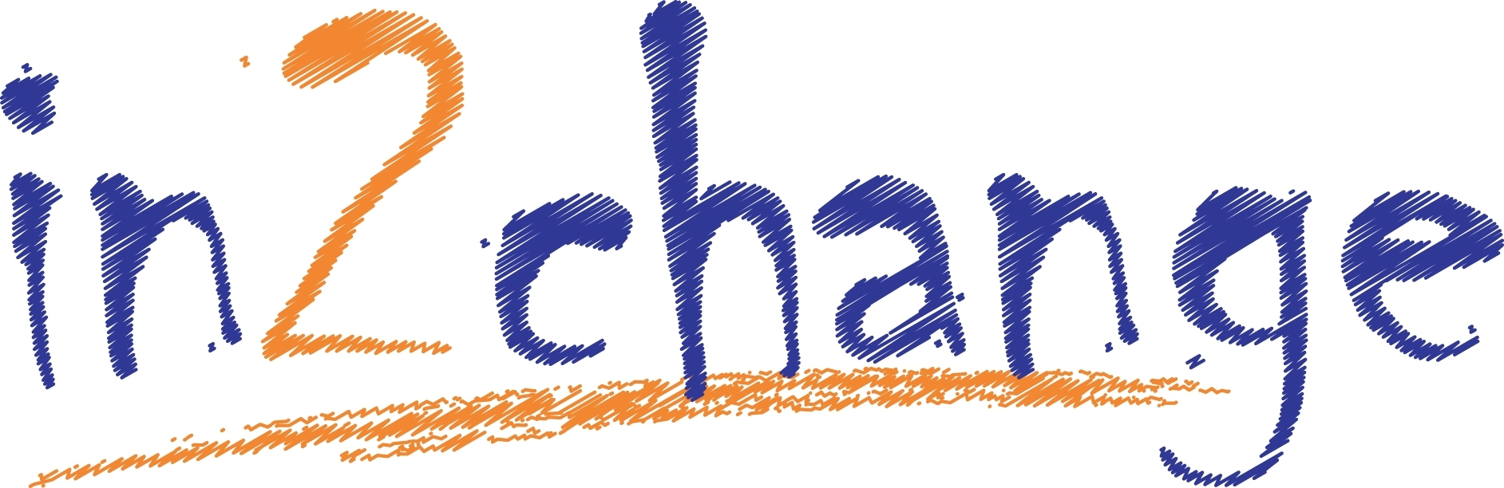


Young Person’s Drug and Alcohol Team Referral Form
in2change work with young people from the age of 11 up until 18 years (inclusive)
Forename: | For office use only  Date referral received:  Ref number:  Re-referral? Yes / No
Surname:

Date of birth: | Age:
Young person’s address: | Which of the following best describes the Young Person’s Gender:  Male  Female  Preferred gender ……………………………………………………………….   Prefer not to say
Post Code: | Parental responsibility/guardian:
Contact number young person: | Relationship:
Contact number parent/carer: | Name of referrer:
G.P’s name: | Designation/relationship of referrer:
G.P’s address: | Referrer address:
School: | Contact number of referrer:
Is the young person aware of the referral?  Yes No  If not why? | Is the parent/guardian aware of the referral?  Yes No  If not why?
Are there any special arrangements or issues to be aware of when contacting young person or parent/guardian?
Yes No
Details:
Young person’s first language: | Is an interpreter/Welsh speaker required?  Yes No
What is the best way to contact the young person? (e.g. Telephone/letter): | Specific requirements: (e.g. sign)
Please state reason for the referral:

Risk Factors: Details of any risks you are aware of? E.g. General and psychological health, social situation/behaviour:

Environmental Risk Assessment: Are there any current or potential risks staff should be aware of?
(e.g. hazards when visiting, does young person pose a significant risk to staff or others?)

Immediate family at home and significant others: (Name and relationship to young person,
Do the parents/siblings require any support?).

Involement with other services: Please state P-Previous, C-Current or B-Both

Police TAC SPOA
YJS Social services CAMHS
Other/further details:

In what ways could in2change help/support this young person (e.g. drug & alcohol education, harm reduction, treatment, signposting, improving social networks, diversionary activities):

Education Motivational Diversionary
Harm Reduction Relapse Prevention Parenting
Other/further details:

Does the young person have a disability (ie. Communication needs, ASD, literacy difficulties)?
Yes No
If yes, further details:
Religion/other cultural issues:
British (White) |  | White & Black African (Mixed) |  | Bangladeshi |  | Any Other Ethnic Group
Irish (White) |  | White & Asian (Mixed) |  | Caribbean (Black or Black British) |  | Any Other Ethnic Group
Welsh |  | Any Other Mixed Background |  | African (Black or Black British) |  | Any Other Ethnic Group
Any Other White Background |  | Indian (Asian or Asian British) |  | Any Other Black Background |  | Any Other Ethnic Group
White & Black Caribbean (Mixed) |  | Pakistani(Asian or Asian British) |  | Chinese (Other Ethnic Groups) |  | Not Stated

On receipt of this refe rral the young person will be allocated a worker based on their needs. The worker will then contact the young person to make arrangements to meet them to discuss in2change and the support they can offer them.
Referrer signature Date:

Please send completed referral forms marked ‘Private and Confidential’ to: in2change@wrexham.gov.uk
Am wybodaeth ynglyn a sut mae Cyngor Bwrdeistref Sirol Wrexham yn defnyddio data personol, gweler yr rhybydd Preifarwydd ar ein safle gwefan: www.wrecsam.gov.uk For information as to how Wrexham County Borough Council handles personal data, please see our Privacy Notices on our website: www.wrexham.gov.uk

